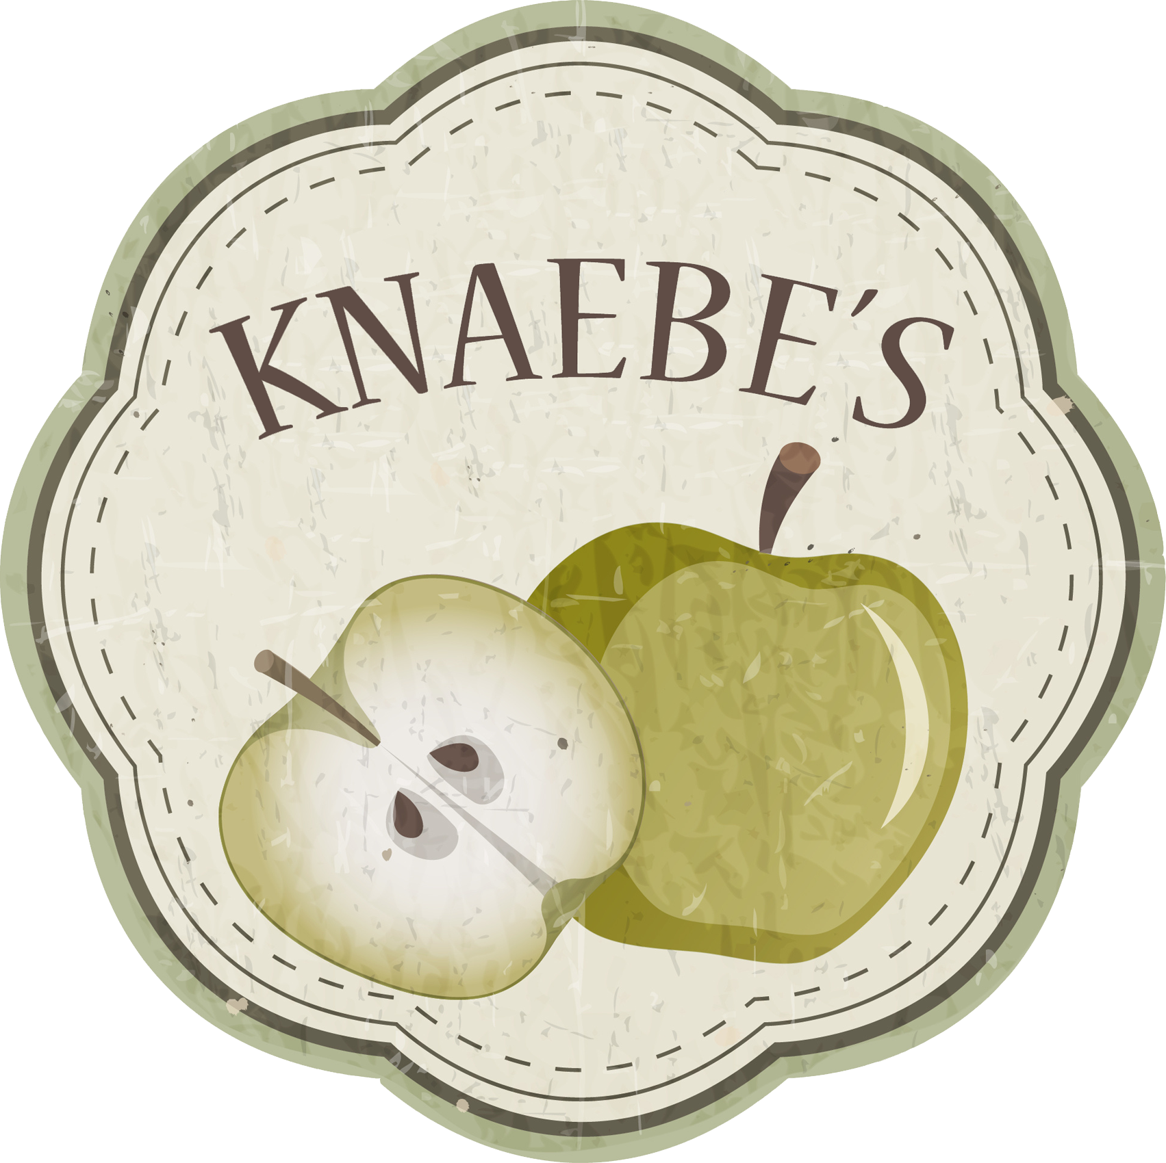

Mmmunchy Krunchy Apple Farm
2621 S. Karsten Road Rogers City, MI
(989) 734-2567 ~ knaebes@gmail.com
mmmunchykrunchyapplefarm.com

What to Know when Booking a Tour:
- Tours can be scheduled on Thursdays and Fridays between 9:30am and 4:00pm
- Tours last about an hour, depending on number of participants
- Tours cost $4.00 per child / $5.00 per adult (one teacher per tour is free), with a minimum charge of $40.00
- One teacher per tour is free
- Please plan for enough adult chaperones to make your farm visit enjoyable for your group and our Apple Corp. Typically, one adult/teacher for every 5-7 tour participants, depending on age.
- Please pay for the tour with a check or credit card the day of your tour
- We can make adjustments as needed for more or less students upon arrival
- We recommend ordering donuts by the dozen or apples by the bushel upon arrival if you wish to take them with you. We can have all orders ready when the tour is complete
- Be sure to dress for the weather, as all tour activities are outside
- If the weather is really bad on the day of your scheduled tour, we'll do our best to reschedule
- Bringing bag lunches? Let us know ahead if you will need picnic tables reserved
- Portable bathrooms and hand washing facilities are available
- Be sure to leave with the same amount of tour participants that came with you

When Scheduling a Tour, We Will Need:
- The number of tour participants and age/grade ($4/student)
- The number of teachers (one free)
- The number of adult/parent chaperones ($5/adult chaperone)
- A contact person and telephone number for the day of your tour
- A complete list of children with compromised immune systems or allergies to fresh apple cider, bees, apples, milk, nuts or gluten (donuts). Please be sure to have all necessary medications and precautionary tools.
WE HOPE YOU HAVE A WONDERFUL TOUR
AND THANK YOU FOR SPENDING YOUR DAY AT KNAEBE'S!

